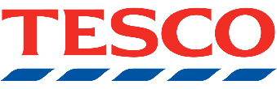

Tesco Stronger Starts - In Store Vote
From 28th APRIL 2026
Help Us Win £1,500!
We’ve applied for a Tesco Stronger Starts Grant and need YOUR help.

How to Vote

Make any purchase in-store
Receive 1 token per transaction
No need to buy a carrier bag
Drop your token into the Broadwater Get FIT box

Where You Can Vote

Worthing Findon Express (BN14 0EL)

Dolphin Dominion Road Express (BN14 8LB)
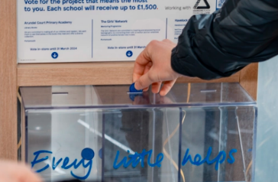
Worthing Broadwater Street Express (BN14 9DA)
Durrington Esso Express (BN13 1QY)
Rectory Worthing Express (BN14 7PE)
Goring Way Express (BN12 4TY)
Worthing South Farm Road Express (BN14 7AB)
Worthing Chapel Road Express (BN11 1EG)
West Durrington Extra (BN13 3PB)
Worthing Goring Road Express (BN12 4AJ)

Prize Breakdown
1st: £1,500
2nd: £1,000
3rd: £500

EVERY TOKEN COUNTS! Thank you for your support
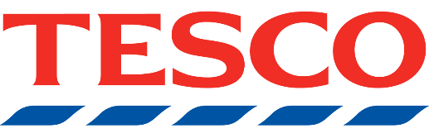

You can vote for us at ALL of the following stores:

Worthing Findon Express BN14 0EL
Dolphin Dominion Road Express BN14 8LB
Worthing Broadwater Street Express BN14 9DA
Durrington Esso Express BN13 1QY
Rectory Worthing Express BN14 7PE
Goring Way Express BN12 4TY
Worthing South Farm Road Express BN14 7AB
Worthing Chapel Road Express BN11 1EG
West Durrington Extra BN13 3PB
Worthing Goring Road Express BN12 4AJ

